Ibrahim Johar Farooqi
BAI-6A
23K-0074
CN Lab - Lab 01 Tasks

In-Lab Tasks
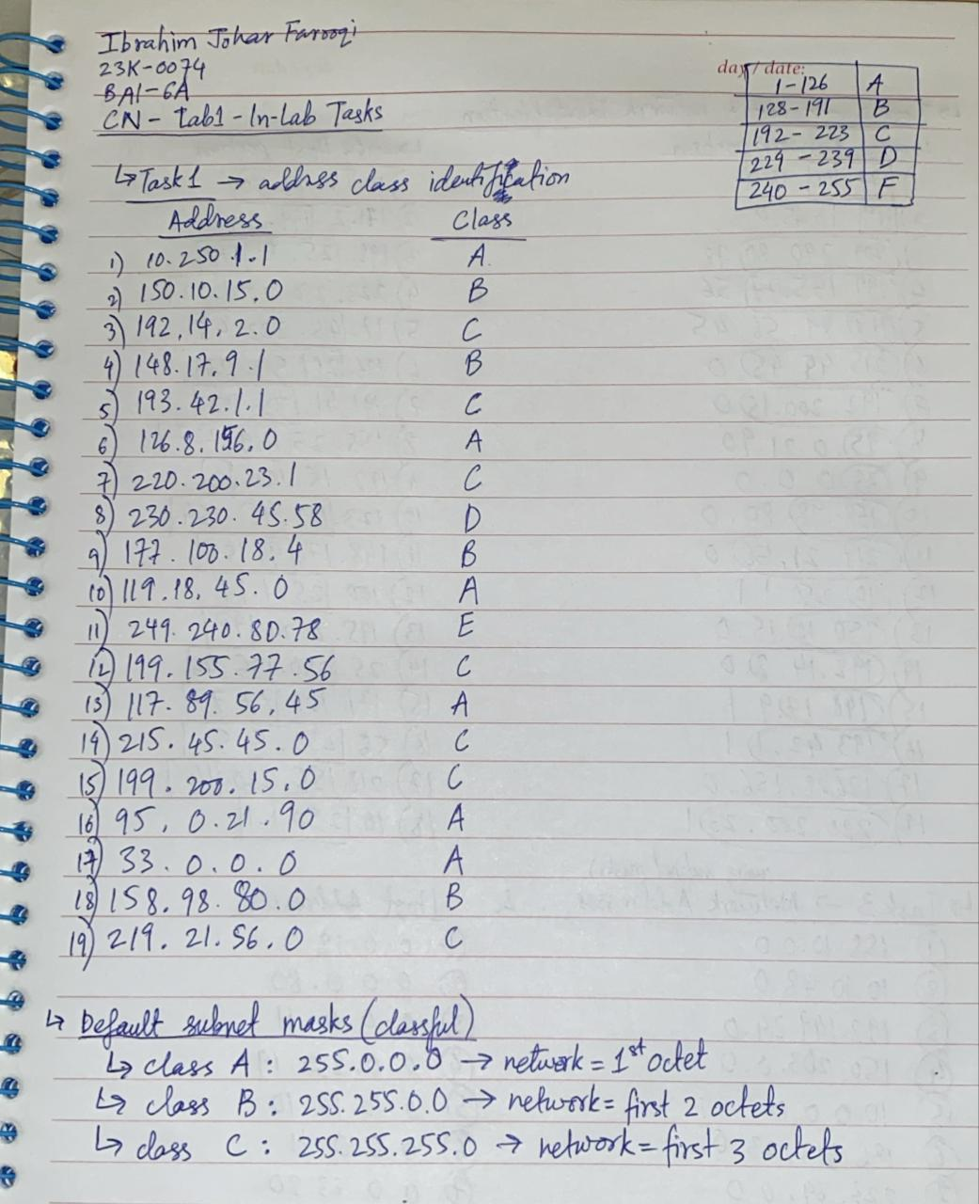

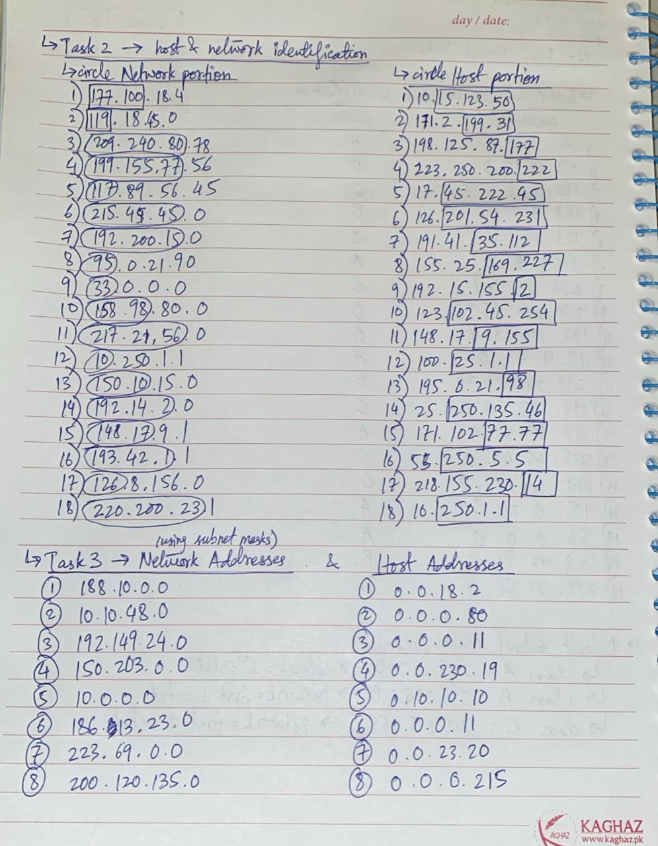

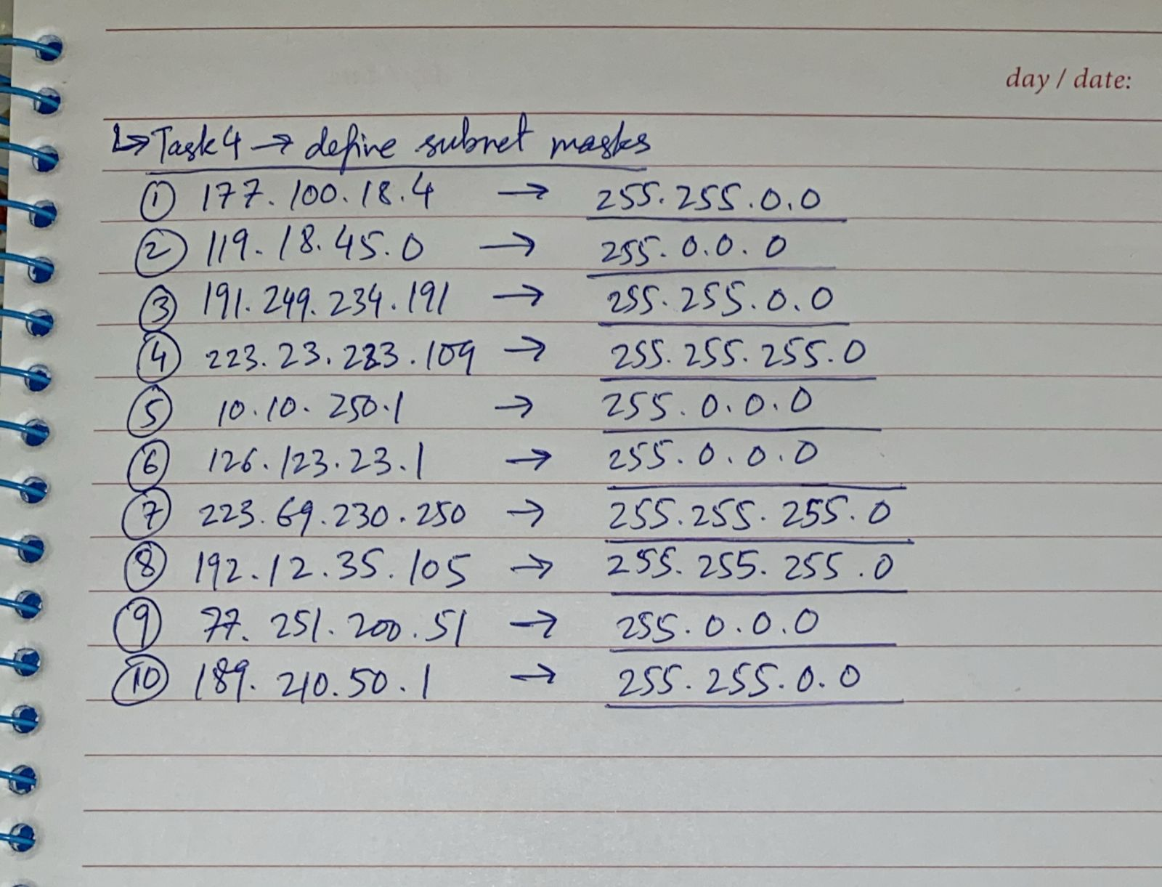

Post-Lab Tasks

Task 1: Find the IP address of the computer you are currently using.
Command: ipconfig
IP Address: 192.168.56.1 (for Ethernet connection) & 192.168.100.6 (for Wi-Fi)
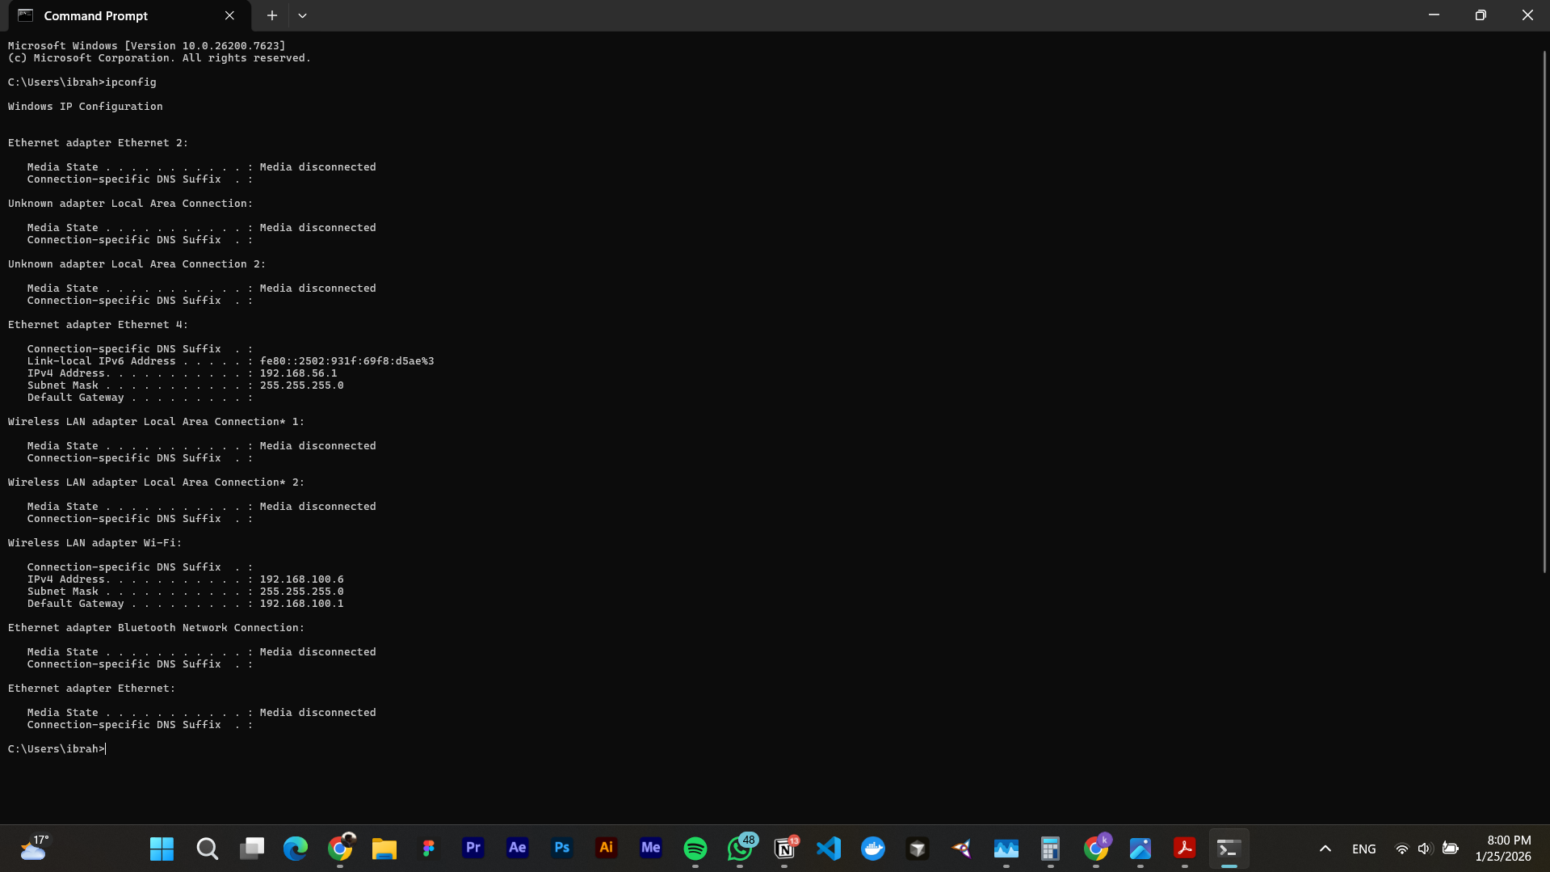

Task 2: Find the IP address of the computer you are currently using, plus MAC address, the gateway, plus whether DHCP is turned on.
Command: ipconfig /all
IP Address: 192.168.56.1 (for Ethernet connection) & 192.168.100.6 (for Wi-Fi)
MAC Address:
- Ethernet:
  - 0A-00-27-00-00-03
- Wi-Fi:
  - 14-13-33-8D-FA-C3
Gateway:
- Ethernet:
  - n/a
- Wi-Fi:
  - 192.168.100.1
DHCP:
- Ethernet: Not Enabled
- Wi-Fi: Enabled
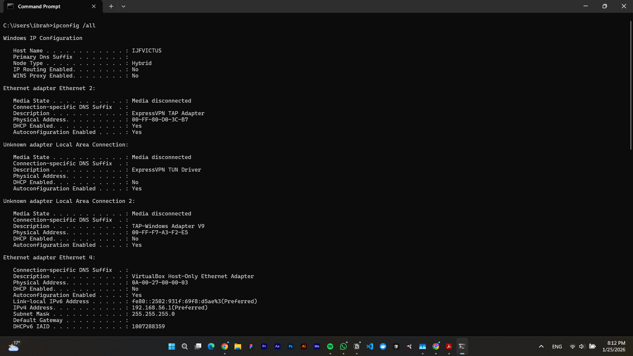
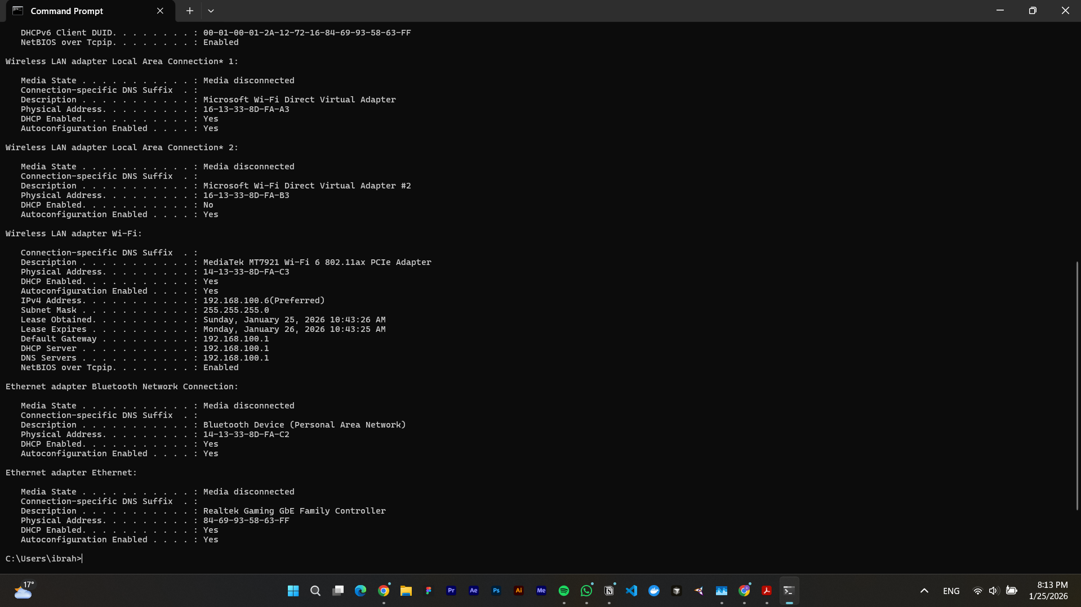

Task 3: Display the host name of the computer.
Command: hostname
Host Name: IJFVICTUS
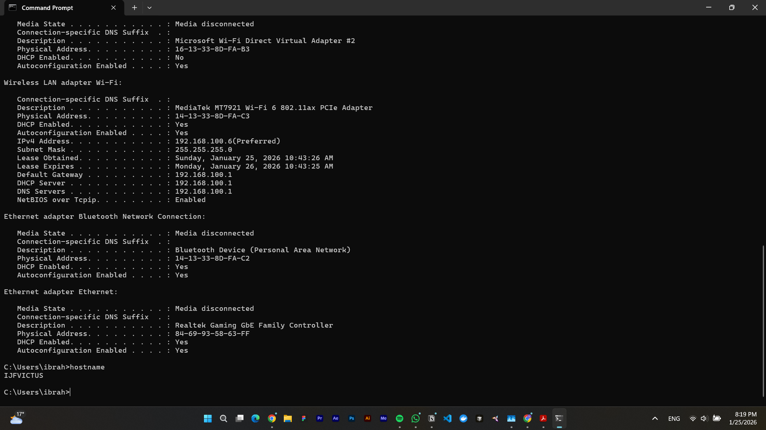

Task 4: Check for basic IP connectivity between two computers by name and IP address. How can basic IP connectivity be checked? What are the reasons why there is no connectivity?
Command: ping
Reason: IP connectivity is checked with the “ping” command, which sends ICMP echo requests to the destination host and then waits for a reply from it. No connectivity may be caused by an incorrect IP address or hostname, the destination device being turned off, or even incorrect network configuration, like a gateway or subnet mismatch.

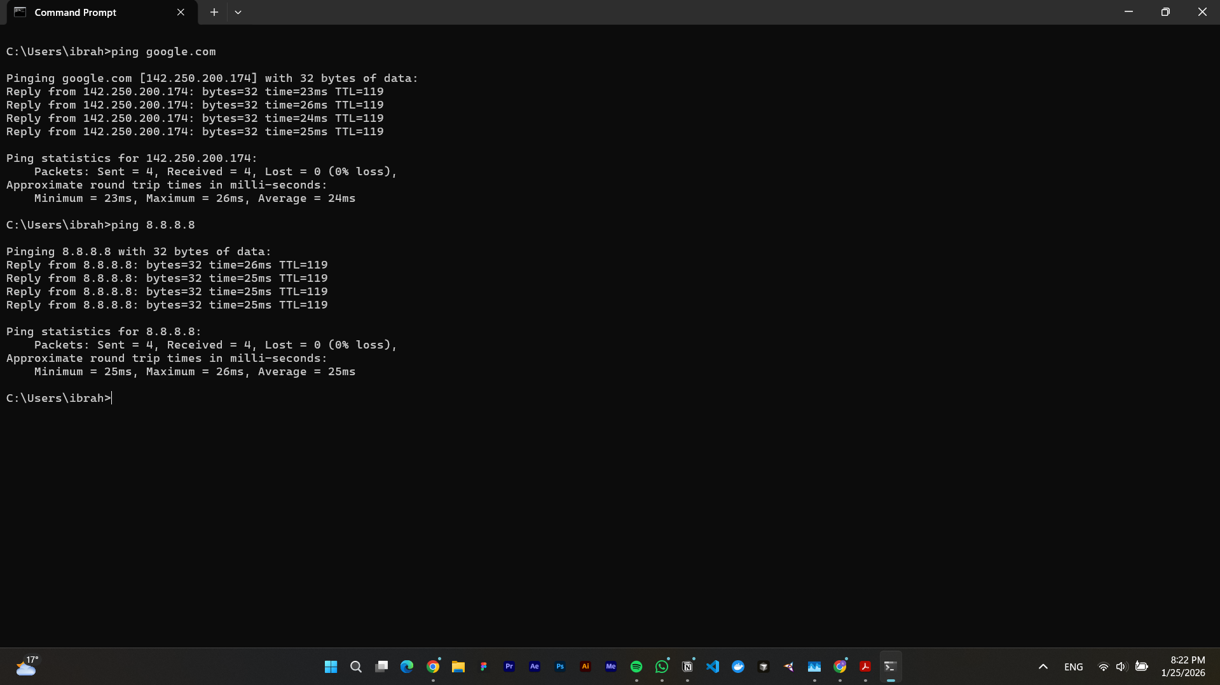

Task 5: Find out which ports on your host are connected to applications. Connect the browser to some external web page before running the appropriate command.
Command: netstat

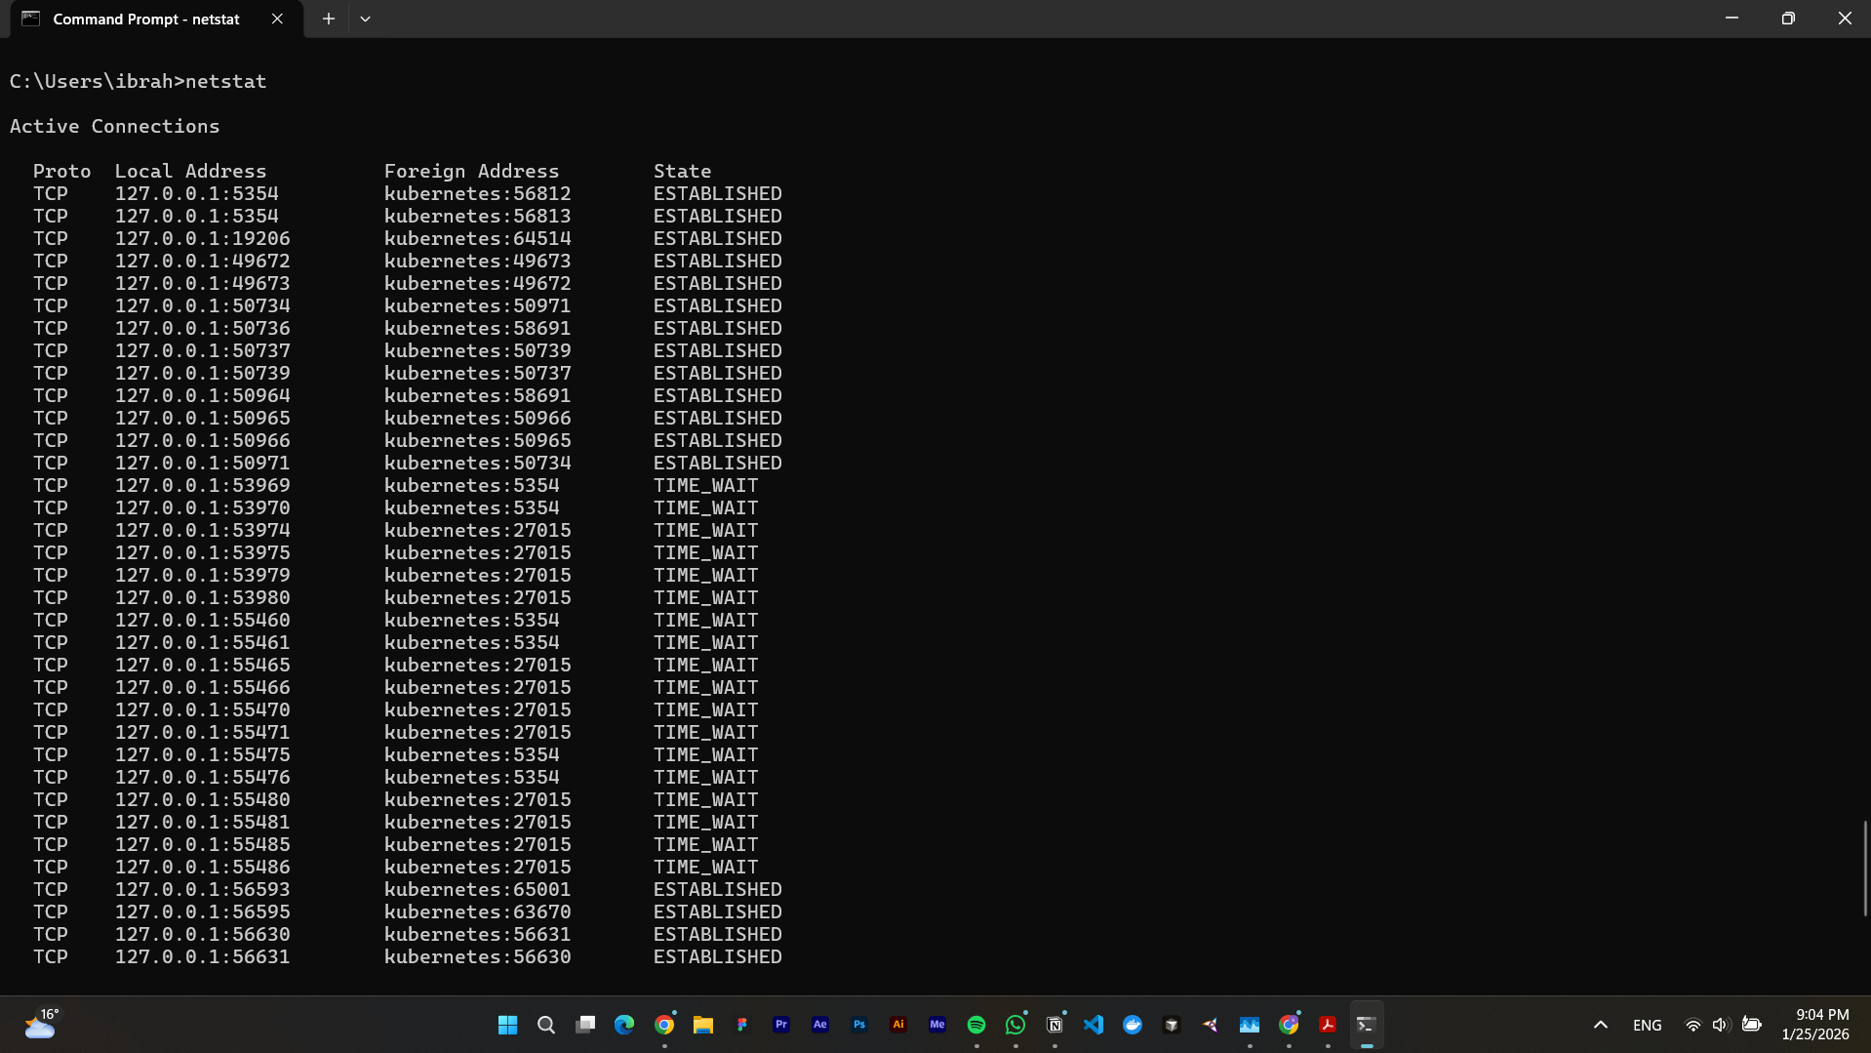

Task 6: Find the path of routers to www.google.com. What is its IP address? How many hops are involved in the path?
Command: tracert www.google.com
IP Address: 142.250.203.164
Total Hops: 9
Traceroute is used to find/trace the path taken by packets from the source to the destination by listing all of the intermediate routers (hops). Some hops may not be able to reply because of a firewall or security restriction.

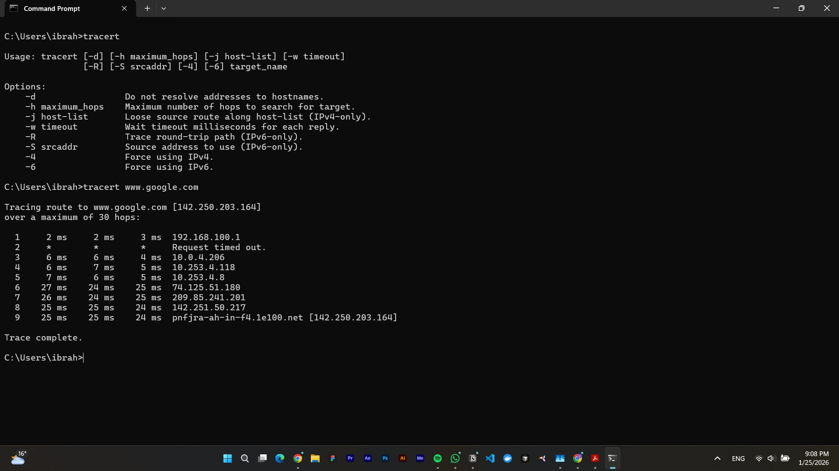

Task 7: A ping to 192.168.0.2 works but a ping to the machine’s name “blue machine” fails. What could be wrong?
Reason: If the ping to 192.168.0.2 works but the ping to the machine’s name doesn't work, that’s because of a DNS or name resolution problem. As the network connectivity seemingly is working due to the correct pinging to the IP address, but the hostname isn’t being translated correctly to an IP address. This is because either the DNS server is not configured correctly, or the hostname is not registered in the DNS. Another possibility is that there is no corresponding entry in the local hosts file, causing this translation problem.

Task 8: Which type of cable will you use to connect in a normal home installation?
Answer: For a normal home installation, a straight-through Ethernet cable is used, as this type of cable is normally used to connect different devices, like a computer to a router.

Task 9: Can you connect a Switch to another Switch or a router to a PC using a straight- through cable? Explain your answer.
Answer: Historically, a straight-through cable couldn’t be used to connect the same type of devices, such as a switch to a switch, but with modern networks, most devices now support Auto MDI/MDI-X, which allows the use of a straight-through cable for such connections, as the devices automatically adjust the transmitting and receiving pins.

Task 10: Write a brief report on your home network or any organizational network, including topology, 1 page max.
Answer: In terms of my home network, a typical home network is a local area network (LAN), which is used for everyday internet access and communication between multiple devices, such as phones and computers, within a limited geographical boundary of a house. The topology used in the home network can be categorised as a “Star Topology.” As all the devices in a home are connected to one central device, the Wi-Fi router. The Wi-Fi router acts as the main point through which all data is transmitted. If any device gets disconnected from the router, it doesn’t affect the rest of the network, which is why Star Topology is considered very reliable and easy to manage. The devices in this network comprise the wireless router, provided by the ISP (Internet Service Provider), as well as laptops, smartphones, and desktop computers. The Wi-Fi router performs several key functions, such as routing traffic, assigning IP addresses using DHCP, and providing wireless access. Devices are connected to the router via wireless connection or through an Ethernet cable for computers and laptops, which is usually a straight-through cable. The router assigns private IP addresses to all of the connected devices and forwards external traffic to and from the internet. The ISP provides DNS services, where it allows users to access websites using domain names instead of just IP addresses. All in all, this network layout provides a very simple but efficient home network that allows regular activities like web browsing and video streaming, etc.

